**Ex.No : 5**

**Date : 24.11.2020**

**Aim:**

To write a python program to check whether the given string is pangram or not. If its not it must print missing characters to make it as a pangram.

**Program:**

def pargram(s):

alpha="abcdefghijklmnopqrstuvwxyz"

a=[pa for pa in alpha if pa in s]

b=[npa for npa in alpha if npa not in s]

if(len(a)==26):

c2s= ''.join([str(elem) for elem in a])

return 'pangram'

else:

c2s= ''.join([str(elem) for elem in b])

return c2s

st=str(input())

st=st.lower()

p=pargram(st)

print(p)

**LINK:** [**http://103.53.53.18/mod/vpl/forms/submissionview.php?id=235&userid=1669**](http://103.53.53.18/mod/vpl/forms/submissionview.php?id=235&userid=1669)

**Output:**

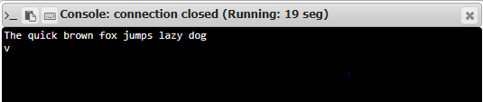

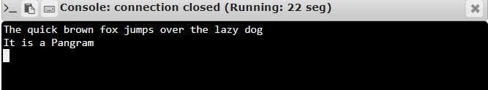

**Result:**

Thus the program to check the given string is pangram or not is executed as per the given conditions and the output is executed.